1. 
2. In last lec, we installed Github Desktop which is GUI for Git. Then we added local repo first-project.
3. 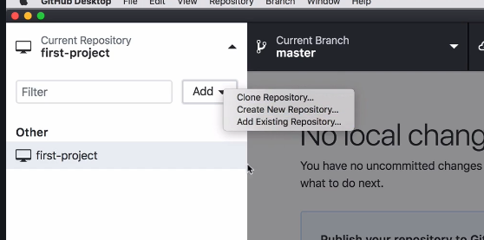
4. 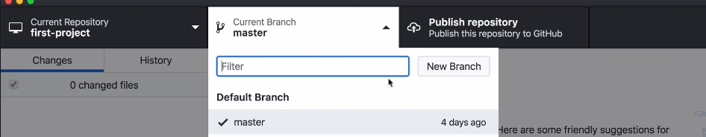
5. 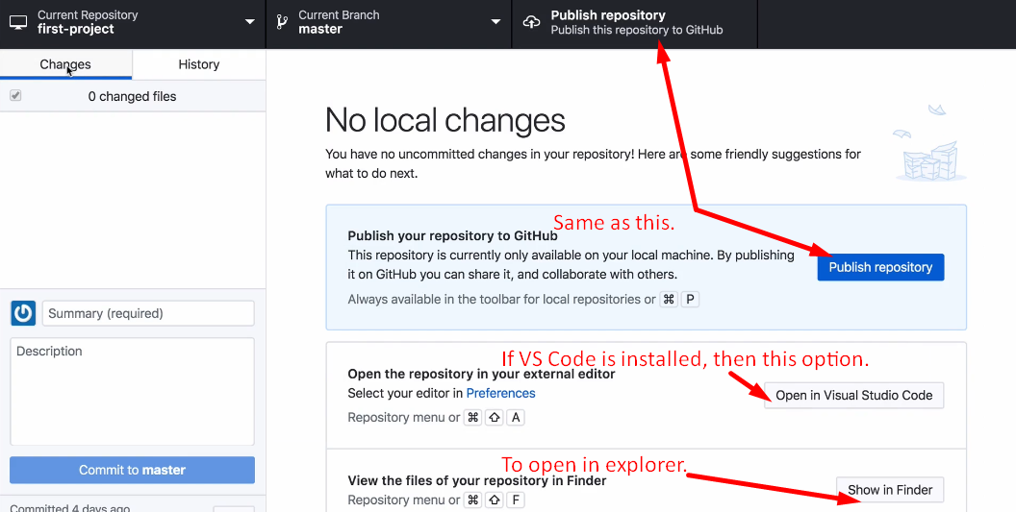
6. 